Exercise 3: Google App Engine SDK and Web App Development
Aim
To install the Google App Engine SDK and develop a Hello World / simple web application using Python.

Procedure
Step 1: Install Google Cloud CLI & Python Ensure Python 3 is installed on the system.
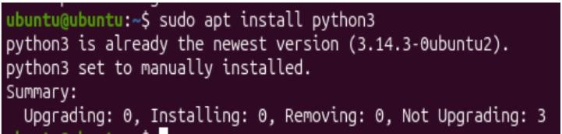
Download and install the Google Cloud CLI (contains the modern App Engine SDK) from cloud.google.com/sdk/docs/install:
curl -O https://dl.google.com/dl/cloudsdk/channels/rapid/downloads/google-cloud-cli-linux-x86_64.tar.gz
tar -xf google-cloud-cli-linux-x86_64.tar.gz
./google-cloud-sdk/install.sh
Step 2: Initialize GCloud & Install Components gcloud init
Sign in to your Google account when prompted.
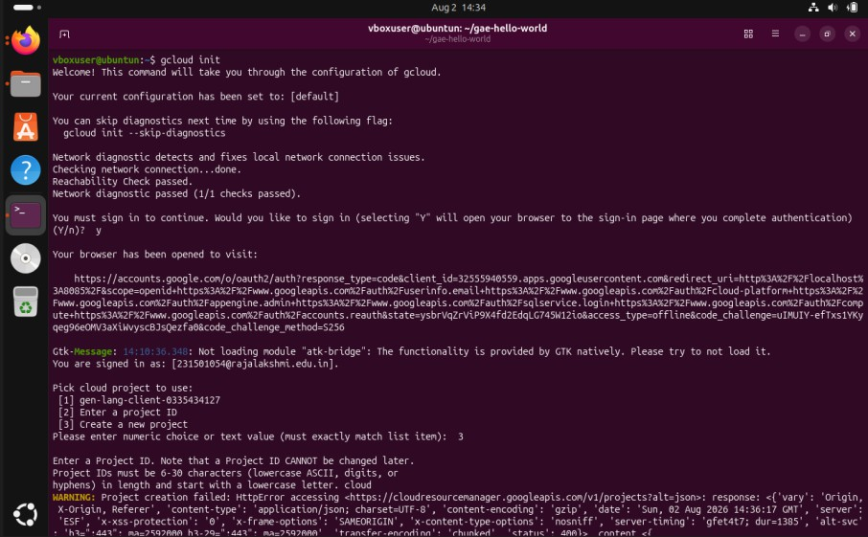

gcloud components install app-engine-python

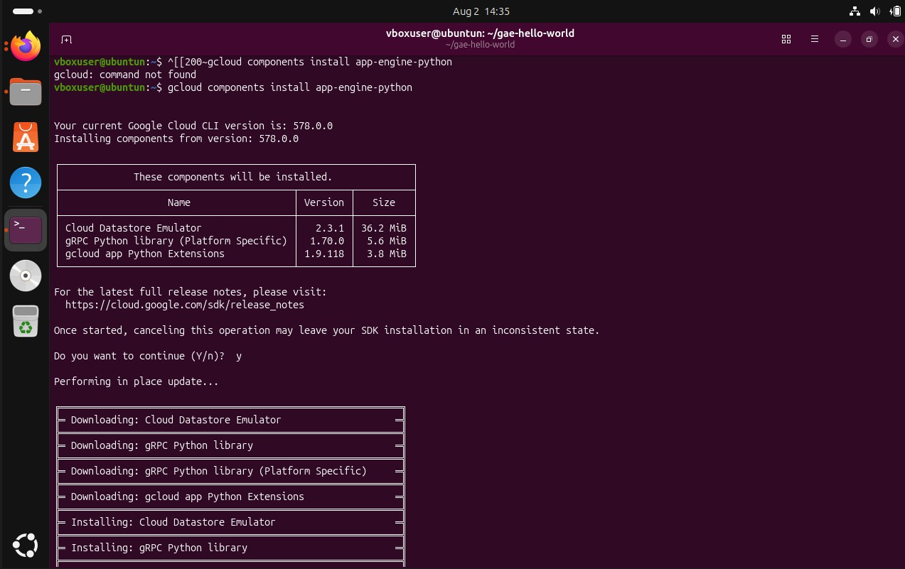
Step 3: Create the App Directory mkdir gae-hello-world
cd gae-hello-world
Step 4: Create Application Code (main.py) from flask import Flask
app = Flask( name )

@app.route("/") def hello():
return "Hello World from Google App Engine!"

if name == " main ": app.run(host="127.0.0.1", port=8080, debug=True)
Step 5: Create Configuration File (app.yaml) runtime: python39
handlers:
- url: /.* script: auto
Step 6: Create requirements.txt Flask==2.0.1
Output
Files created in project directory (main.py, app.yaml, requirements.txt):

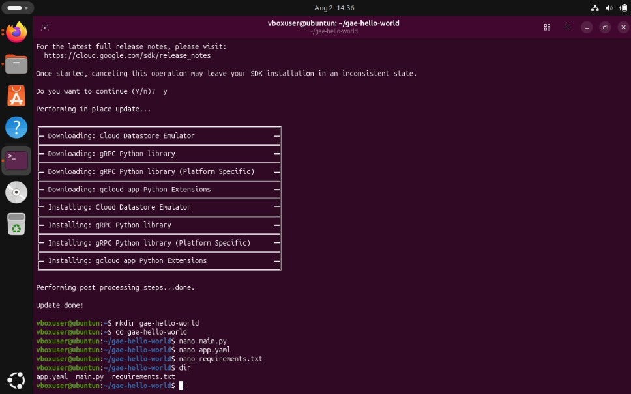
Result
Thus, the Google App Engine SDK was installed and a simple Hello World web application was developed using Python and Flask.

